3.

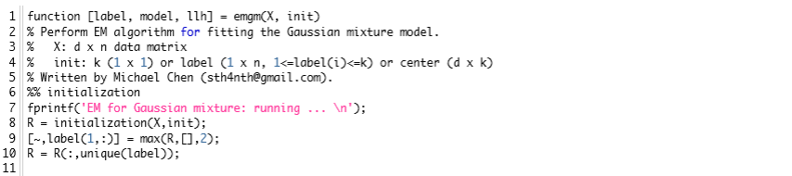

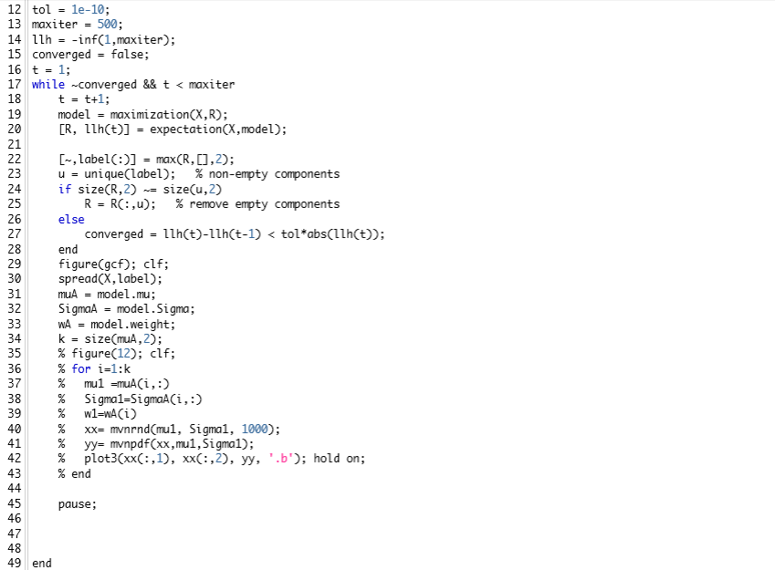

stop criteria

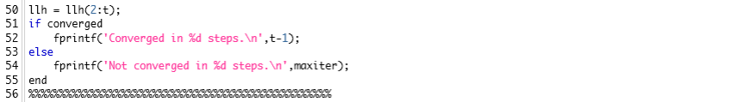

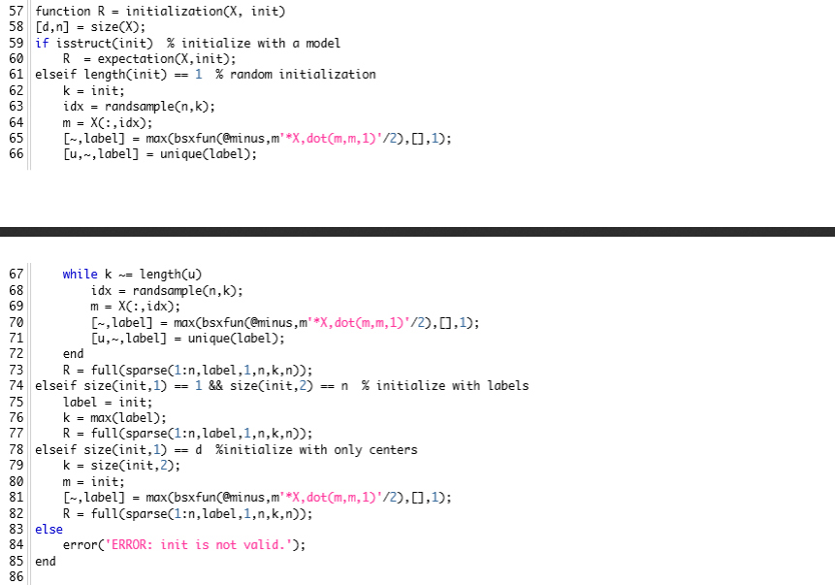

There is the possibility to pass the initial parameters to function,

or

the program could set the initial values randomly

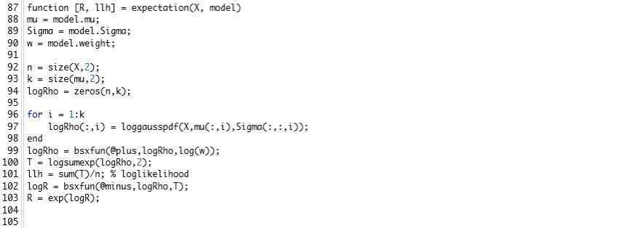

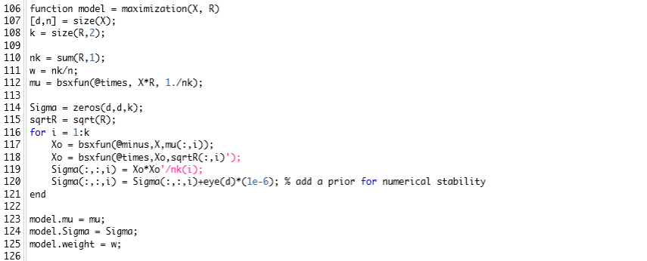

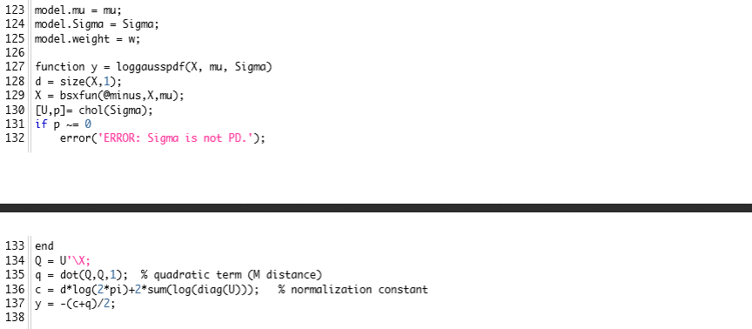

5.

a.

$$\frac{P(A,B,C)}{P(B,C)}×\frac{P(B,C)}{P(C)}=\frac{P(A,B,C)}{P(C)}= \frac{P(A,B,C)}{P(A,C)}×\frac{P(A,C)}{P(C)}$$

$$P\left(A | B,C\right)×P\left(B | C\right)= P\left(B | A,C\right)×P(A|C)$$

$P\left(A | B,C\right)= \frac{P\left(B | A,C\right)×P(A|C)}{P(B|C)}$

b. We need to find k which is the number of times we tosses the coin until we convinced

$$Pr⁡(DH|k heads)≥1/2$$

Pr(DH|k heads) = =

= = =

🡪 k $≥log⁡(F)$